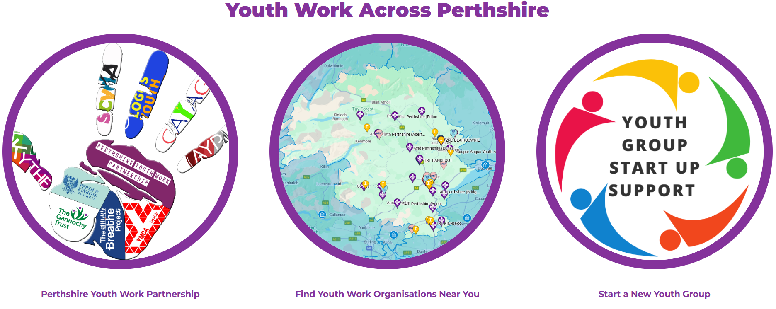
To add your Youth Work provision to the map of provision at www.perthshireyouthwork.org , please complete and return this form to steven.greig@gannochytrust.org.uk

Organisation Name and address (with postcode):

Who is it open to? (Age/Gender/Interests):

When does it meet?:
Is there a cost?:
Who to get in contact with for more information:
Very short description (approx. 40 words):
URL link to your website or Social Media:

